Electronic Invoice Monitoring and Move BOT

Process Design Document

ZingerPay

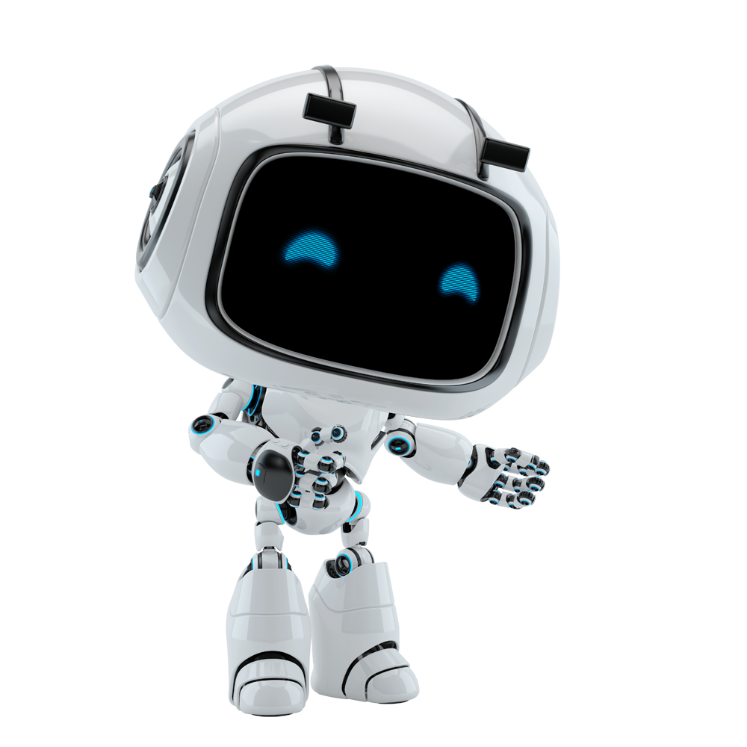

**Robotic Process Automation**

Contents

1. Document Overview 4

2. Automated Master Project details 4

3. Runtime Guide 5

3.1 Runtime diagram [Architectural structure of the Master Project] 5

3.2 List of packages 5

3.3 Master Project Runtime details 6

4. Project details 6

4.1 Project Name: 7

5. Other Details 8

5.1 Future improvements: 8

5.2 Debugging tips: 8

5.3 Other Remarks: 8

6. Post UAT specifications 8

7. Glossary 9

Document History

|  |  |  |  |  |  |  |
| --- | --- | --- | --- | --- | --- | --- |
| Date | Version | Role | Name | Organization  Department | Function | Comments |
| 9/28/20 | 1.0 | Developer | Henry Udeh | Automation | Developer |  |

Version Control

|  |  |  |  |  |  |  |
| --- | --- | --- | --- | --- | --- | --- |
| Date | Version | Role | Name | Organization  Department | Function | Comments |
| 9/28/20 | 1.0 | Author | Henry Udeh | Automation | Developer |  |
|  | 1.0 | Peer Reviewer | Stanley Okorie | Automation | Developer |  |
|  | 1.0 | Reviewer | Santosh S. | Quality Control | Quality Control |  |
|  | 1.0 | Approver | Swarup G. | Automation | RPA Solution Architect |  |

## Document Overview

This document is meant for the RPA COE, IT Support and RPA supervisor to help by providing a snapshot of the automated process details and components. It can as well serve developers to have a quick glance at the setup, before diving into the code, to troubleshoot or update changes.

This document is to be completed by the RPA Solution Architect and RPA Developer who automates the business process and reviewed by the RPA Solution Architect prior to handover to RPA Operations.

The purpose of this document is to record the outcome specific to the automated master project and its subcomponents: projects, workflows, sequences etc.

This Document is created for every business process that is automated using the RPA technology. The document needs to be reviewed and updated for every change requested and applied to the automation process. This document will provide a technical snapshot and must always reflect the latest design and key features of the automated workflow.

## Automated Master Project details

Details filled in by the developer reflect the actual information for the master project released for production.

|  |  |  |
| --- | --- | --- |
| # | Item | Details  (Fill in with free text. If not applicable, mark the field as “n/a. No empty fields.) |
| **1** | **Master project name and version** | Compliance Bot |
| **2** | **Robot type**  **(attended, unattended, hybrid)** | unattended |
| **3** | **Is Orchestrator used?** (Yes/ No) | Yes |
| **4** | **Scalable?** (Yes/ No)  (can the process be run by multiple robots in parallel) | Yes |

## Runtime Guide

### Runtime diagram [Architectural structure of the Master Project]

Display the interaction between components (package / robots, Orchestrator queues, and running

order).

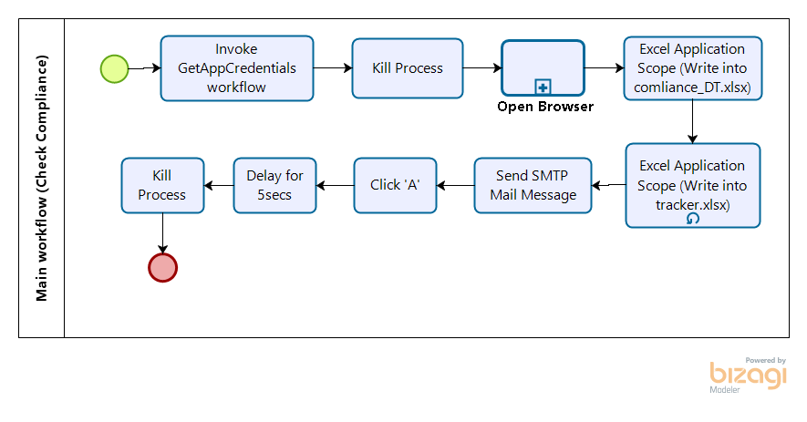

### List of packages

Include **the list of packages and the high level description** for each of them, to explain each one`s purpose :

|  |  |  |
| --- | --- | --- |
| # | Package name | High Level description |
| 1 | UiPath.Credentials.Activities | * These activities is used to retrieve credentials or simply prompt a human user to introduce his credentials, |
| 2 | UiPath.Mail.Activities | * The pack is designed to facilitate the automation of any mail-related tasks, covering various protocols, such as **IMAP, POP3**or**SMTP, outlook and exchange.** |
| t | UiPath.System.Activities | * Contains all the basic activities used for creating automation projects. |
| 4 | UiPath.UIAutomation.Activities | * Performs mouse and keyboard commands or typing and extracting text, for basic UI automation. * Use technologies such as OCR or Image recognition to perform [Image and TextAutomation](https://studio.uipath.com/docs/about-image-and-text-automation). * Perform browser interaction and window manipulation. |
| 5 | UiPath.Excel.Activities | * The Excel activities package aids users to automate all aspects of Microsoft Excel. |
|  |  |  |

*\*Add more rows to the table to include all the project names and version. No fields should be left empty. Use “n/a” for the items that don`t apply to your project.*

### Master Project Runtime details

Details of the automated process:

|  |  |  |
| --- | --- | --- |
| # | Item | Details  (Fill in with free text. If the section does not apply to your automation, mark the field as “n/a”. No empty fields. ) |
| **1** | **Production environment details** | Orchestrator |
| **2** | **Prerequisites to run** | * Set up credential name in Orchestrator and make sure the credential Name is matching the value in your config file. * Add your Credentials in Orchestrator. |
| **3** | **Input Data** | 1. username 2. password 3. year 4. month 5. day |
| **5** | **How to start the automated process?** | * Click on Debug button on Uipath Studio to start the process or start the process from UiPath Assistant or start a job from orchestrator if the project was published to orchestrator. |
| **6** | **Resuming the process from a particular step** | Right click on the particular activity you want to run and select run from this particular activity. |
| **7** | **Reporting**  (queues reporting, Kibana or another platform) | TBD |
| **8** | **Manual Error Handling**  (roll back or manually complete failed transactions). Procedures to reset the item. Ex “set status as investigating” | * Process Finished due to no more transaction data. * Read range (Settings and Constants sheets): The process cannot access the file excel.xslx * Throw: No credentials supplied * Cannot find UI element |
| **8 a. How to resume the process in case of error** | * Stop the automation and run the add attachment bot again to populate the Queue Item. |
| **8 b. How to manually fix transactions with error** | * The process cannot access the file can be fixed by closing any open file used by the automation workflow. * Check if your internet access is active and make sure you’re still connected to Orchestrator so your credentials will be fetched from there Otherwise provide your login details and click “ok”, your credentials   will be stored in windows credential manager.   * Retry the automation If the bot cannot find the UI element to interact with due to network delay. |
| **9** | **Use of Orchestrator** | Yes |
| **Password policies**  (specific compliance requests?) | TBD |
| **Stored Credentials:**  (Never hardcode credentials in the workflow) | Store Credentials in Orchestrator |
| **List of Asset Names:**  (Follow naming convention ProcessName_AssetName) |  |
| **List of Queues Names**  (Follow naming convention ProcessName_QueueName) |  |
| **Schedule details:** | Schedule the robot in orchestrator to run the job |
| **10** | **Multiple resolutions supported**  (in case of image automation/ Citrix) | N/A |
| **Recommended resolution** | N/A |

## Project details

In this section describe all the projects that compose the automated process.

For each project, describe the workflow(s) in the logical order that they are called in.

If the workflow is a flowchart, also include the exported image from Studio.

**If the automated process is composed of multiple projects, copy paste and fill in the table below for each project with its specific details *(Sections 4.1 ; Section 4.2 etc)***

### Project Name: **Compliance Reviewer Bot**

*Add to the title of this section the actual project name of the automated process.*

|  |  |  |
| --- | --- | --- |
| # | Item name | Details  (Fill in with free text. If not applicable, mark the field as “n/a. No empty fields.) |
| **1** | **Environment used for development**  (name, location, configuration details etc) | HP, core i5 CPU @2.60GHZ |
| **2** | **Environment prerequisites**  (OS details, libraries, required apps) | Windows Os, CPU -   |  |  | | --- | --- | | 2 x 1.8GHz 32-bit (x86) | 4 x 2.4GHz 64-bit (x64) |   Recommended - 4 x 2.4GHz 64-bit (x64)  RAM -   |  |  | | --- | --- | | 4 GB | 8 GB |   Recommended – 8 GB |
| **3** | **Logging level** | Information |
| **4** | **Details about automation** (if the apps were automated using UI Automation, Image & Text) | Email automation, OCR, excel automation |
| **5** | **In case of Front Office Robot, can the user operate the computer while the robot is running?** | Yes |
| **6** | **Repository for project**  (where the developed project is stored) |  |
| **7** | **List of reused components** | The workflow can be reused on other computer |
| **8** | **Custom logs defined in the workflows**  **(**where Throw Activity was used or custom log message was defined**)** | |  |  | | --- | --- | | No |  | |  |  | |
| **9** | **Frequent errors found in the development phase** |  |
| **10** | **Workarounds used in the automation phase** |  |
| **11** | **Configuration method**  (assets, excel file, Json file) | Configure assets name in orchestrator. |
| **12** | **Configuration details**  (path for input files, configuration Orchestrator assets used) | Configuration settings for  Variable   * **username**: This is a variable binding the username value from the get credential activity. * **password**: This is a variable binding the password value from the get credential activity. * scope. * **Zingerpay_Url**: Variable storing zingerpay Url. * **Preparer**: the account prepare of the transaction * **Reviewer** : the account reviewer for each transaction. * **Year**: the year to search * **Compliance_DT**: datatabel extracted from zingerpay table * **myCompliance_DT**: data output from the read range excel * **rowNum**: check row count which is assigned 0 |
| **13** | **Workflow File Export List**  (Use this [TOOL](https://drive.google.com/open?id=0B_Ti7JQEeRYvS3ktRHJiUzhJa0U)) | Names of the export, moved, renamed………….. |

### Workflow(s) specific to **Compliance Send Bot**

*Add to the title of this section the actual project name to which the workflows are specific to. The name should normally coincide with the Project name mentioned at Section 4.1*

Define below all the workflow files ( xaml files) used in the project, with the Input and Output data.

|  |  |  |  |  |
| --- | --- | --- | --- | --- |
| # | Workflow file name | Description | Input Argument | Output Argument |
| 1 | getappcredentials.xaml | This is where the login workflow is created |  |  |
| 2 | Main.xaml | The main.xaml contains all the workflow files used in the project and it should be the one to run anytime you want to run the entire workflow. |  |  |
| 3 | project.json | Text document containing the keyword based classifier information. |  |  |
| 4 | tracker.xlsx | The extracted data file from zingerpay table. |  |  |

*\*Add more rows to the table to include all the workflow file names. No fields should be left empty. Use “n/a” for the items that don`t apply to your project.*

*If the workflow is a flowchart, also include below the exported image from Studio.

**Start the list with the one that will run by default when the package is executed.

## Other Details

### Future improvements:

## ??????

### Debugging tips:

Click on the Debug button and select step into to run the files one after the other. Use the breakpoint button to add a break to an activity.

### Other Remarks:

???????

## Post UAT specifications

**Average duration per transaction**: 41s

**Recommended number of robots for the specified volumes**: 1 at least

**Specified schedule**: Run every 5 minutes

## Glossary

**Master project** - the overall output of the development, containing one or multiple projects that together cover the scope of the robotic process automation.

**Project** - an UiPath Studio project containing one or multiple workflow files. A project can be converted to a package and run independently, covering a particular scope within the master project. The project is used when defining the development and support phase of the automation.

**Package** - the output of compiling a project. A package can be deployed on the robot machine and be executed by the robot service. Only one package can be executed at a given time by a robot. The package is used when defining the running phase of the automation

**Workflow** - a component of the package, the workflow encapsulates a part of the project logic. The workflow can be of type: sequence, flowchart or state machine. a workflow is saved as an .xaml file inside the project folder. A workflow file can be invoked from another workflow and by default there is an initial workflow file that will run when executing the package.

**Activity** - an action that the robot executes.

**Sequence** - a workflow where activities are executed one after another, in a sequential order

**Flowchart** - a workflow where activities are connected by arrows and the logic of the workflow can be easily followed in a visual manner. The flowchart can also be exported as an image from UiPath studio

**State machine** - a more advanced way of organizing a workflow, similar to a flowchart.

**BOR** - Back office robot

**FOR** – Front office robot

**Orchestrator** – Enterprise architecture server platform supporting: release management, centralized logging, reporting, auditing and monitoring tools, remote control, centralized scheduling, queue/robot workload management, assets management.